# OUTPUTS:-

1. Exercise 2: E-commerce Platform Search Function

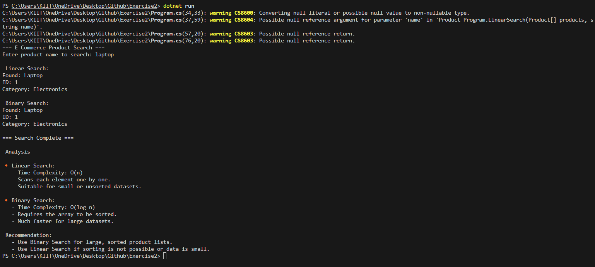

1. Exercise 7: Financial Forecasting

